**Email Encryption**

**What is encryption?**

Encryption is the process by which information is encoded so that only an authorized recipient can decode and consume the information. Cowboy Mail uses encryption in two ways: in the service, and as a customer control.

**How do I send an encrypted email?**

By default, all emails sent through Cowboy Mail are encrypted. However, if the domain it is being sent to is not set up to receive encrypted emails, it will be unencrypted.

To send an encrypted email in **Cowboy Mail**, create a new email as normal, but with the Subject line like this: “[encrypt] YourSubjectHere”

Note: Be sure to put a space between the brackets and the rest of the text in the Subject.

**How do I open an encrypted email?**

Using a client other than Outlook

1. When you receive an encrypted email, you will get the following message:

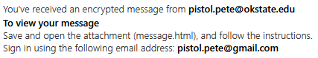

1. Download the attachment that was sent with the email and open it. You will be redirected to an Encrypted message page like this:

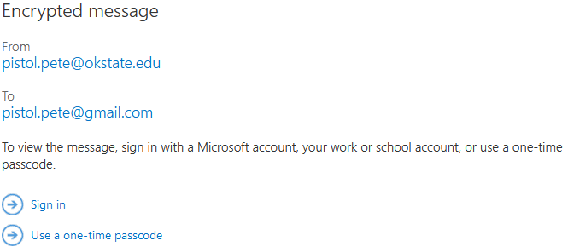

1. Select “Use a one-time passcode”
2. A passcode will be sent to your email, enter that passcode into the field and click Continue.
3. After entering the code, you will be taken to the encrypted email.

**What method of encryption is used by Cowboy Mail?**

Cowboy Mail uses Transport Layer Security (TLS) to encrypt emails.

A full explanation of our encryption can be found at: <https://docs.microsoft.com/en-us/microsoft-365/compliance/email-encryption?view=o365-worldwide>