How to Block/Allow senders for your Inbox

**Note: This is only available to Staff/Faculty**

1. Go to [spam.okstate.edu](http://www.spam.okstate.edu) and enter your O-Key credentials.
2. On the left side of the screen under the “Lists” header, click either “Safe Senders List” or “Blocked Senders List”

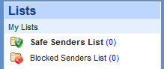

1. To add a new entry, click the “New” button on the top of the screen.
2. It will ask to enter a specific e-mail address or domain to add to the list.

Examples: “pistol.pete@okstate.edu” or “@okstate.edu”

1. Click Save to add it to the list. Repeat this process for any additional entries.