How to Print attachments from Outlook without saving them

**Single Attachments**

1. In Outlook, click on the message with an attachment. Click the arrow next to the attachment name.

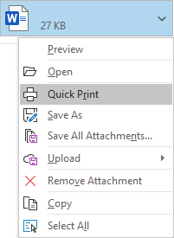

1. Select “Quick Print” from the drop-down box.
2. A prompt will appear asking if you’d like to Open or Save the document. Click Open.

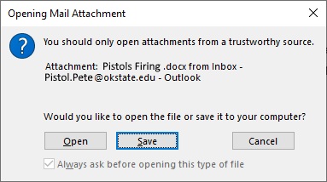

1. This will print the document to your default printer.

**Bulk Attachments**

1. In Outlook, click File, Print, and Print Options

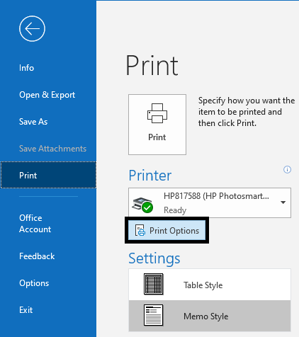

1. Check the box next to “Print attached files. Attachments will print to the default printer only.” Then click Preview

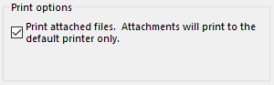

1. Hit the back arrow and go to the email you’d like to bulk print attachments from. Right-click it and select Quick Print.

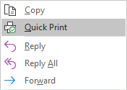

1. A prompt will appear asking if you’d like to Open or Save the document. Click Open.



1. This will print the documents to your default printer.