**Office 365 Installation**

1. To download Office 365 Applications on your computer, login to your Cowboy Mail account using <http://cowboymail.okstate.edu/>. For help logging into your Cowboy Mail, [check the OSU IT Website](https://it.okstate.edu/services/cowboy-mail/index.html).
2. From here, click your account icon in the top right and select My account.

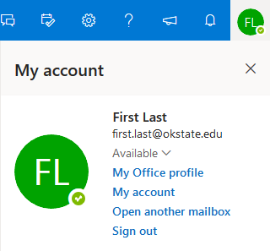

1. On this screen you will see an option to View apps & devices. Click this button. You will see two options listed, one to Install Office and the other to Install Skype. Install Office will provide you with all the apps listed above. If you’d like to use Skype for Business, choose the Install Skype option.
2. After clicking Install Office/Install Skype a prompt will appear. Follow the on-screen instructions to complete the installation

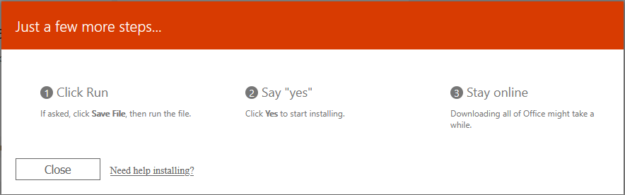

1. When the installation process is complete, you’ll be able to use the Office applications.