Login Issue for Cowboy Mail from a Browser

If you’ve recently reset your O-Key password, your web browser may have saved your old password, preventing you from logging in. To fix this, please follow the steps below.

1. When logging into cowboymail.okstate.edu, you will be prompted with a screen showing your O-Key login address.

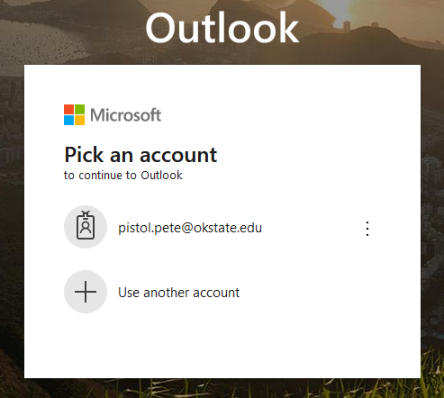

1. Select the three dots to the right of your email address, and select “Forget”

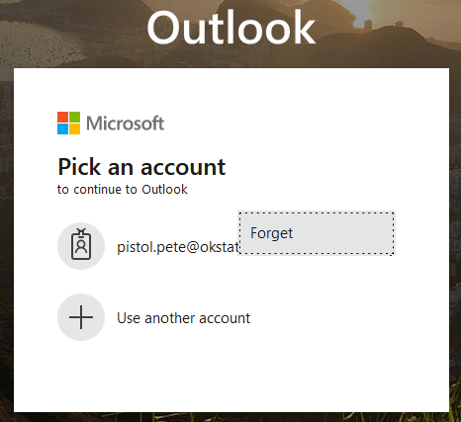

1. After this you will be able to sign into your account as usual.