How to setup an Orange Mail account on the iPhone Gmail App

1. Go to okey.okstate.edu and sign in.
2. Click the Orange Mail link on the left side of the screen. Write down the Login Address.

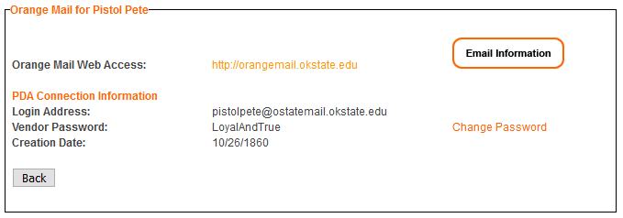

1. On your mobile device, go to the [App store and install Gmail](https://apps.apple.com/us/app/gmail-email-by-google/id422689480). Once it is installed, open the app.

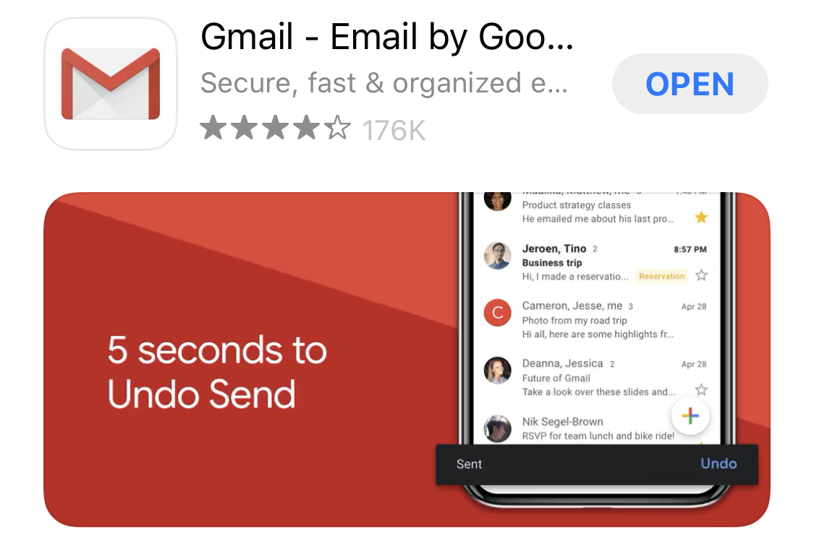

1. Click “Sign in” on the bottom of the screen. Select “Google” for the email.

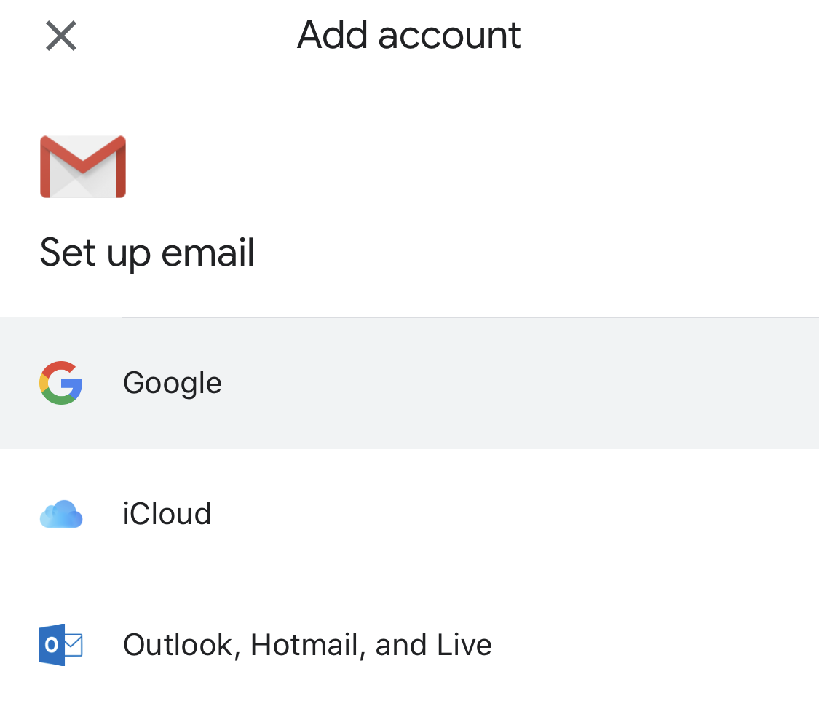

1. You will be prompted letting you know Gmail wants to use google.com to sign in. Select “Continue.”

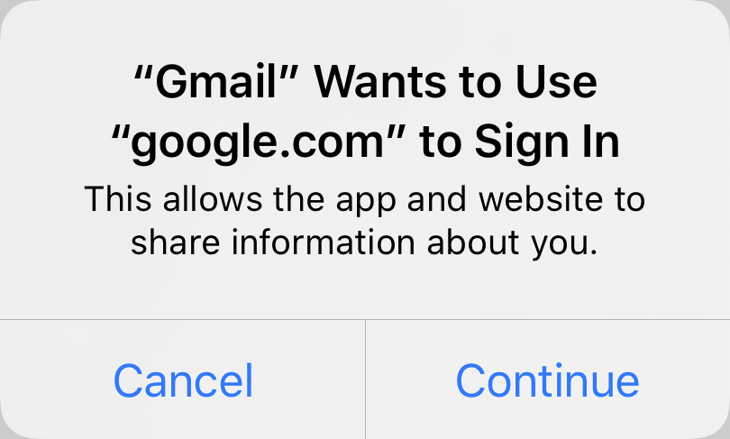

1. Enter your Login address from O-Key.

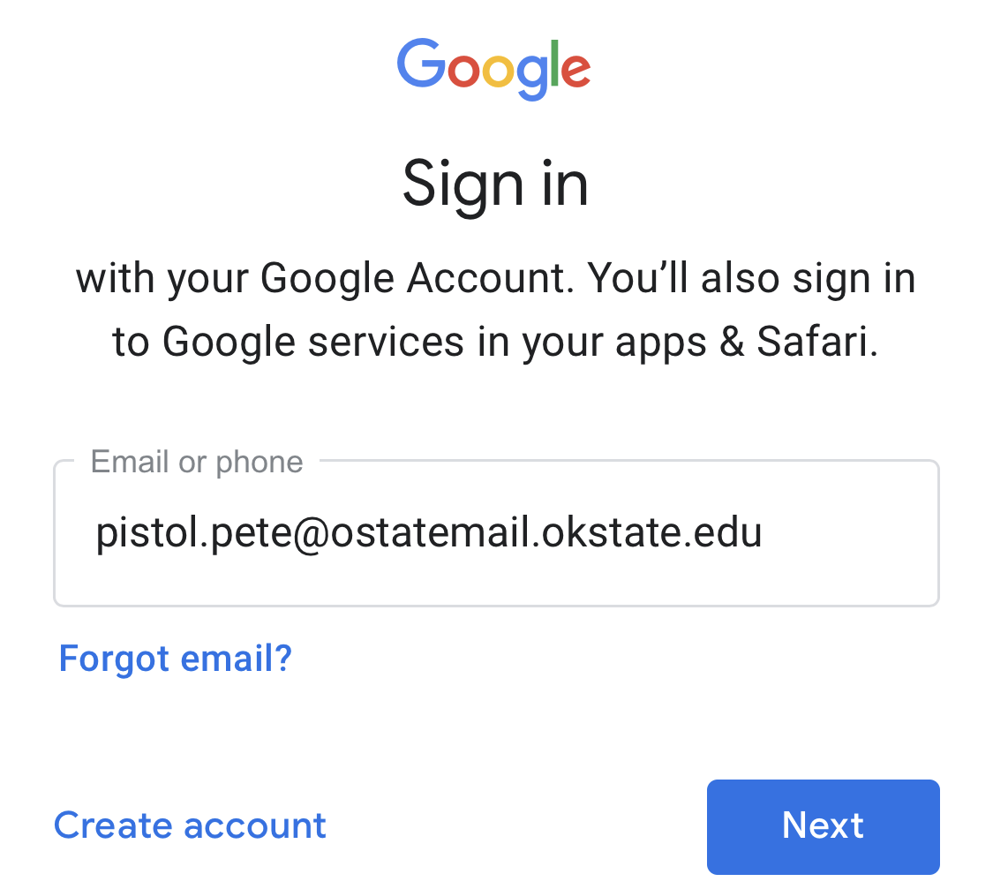

1. You will be redirected to an OSU login page, enter your O-Key credentials.

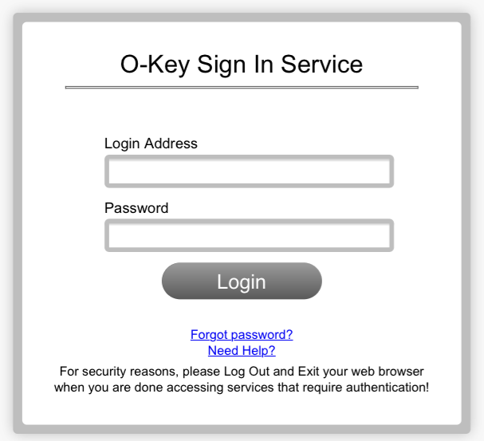

1. Your email is ready to use!