# How to Locate IPv4 Address on iPhone

# Details

An Internet Protocol (IP) address is a unique numerical value assigned to each network device. IP addresses are used for identifying and locating a device on a network.

On a device with both wired (Ethernet) and wireless (Wi-Fi) network connectivity capabilities, there will be one IPv4 Address for the wired (Ethernet) connection and another IPv4 Address for the wireless (Wi-Fi) connection. If a device only has wired (Ethernet) or wireless (Wi-Fi) network connectivity capabilities, then there will only be one IPv4 Address.

1. On your Apple device, go to the device **Settings** by clicking on the Settings icon.

1. In Settings, click on the **Wi-Fi** tab. A screenshot of a phone

   Description automatically generated with medium confidence
2. In the Wi-Fi section, click the information logo of the network the device is connected to.

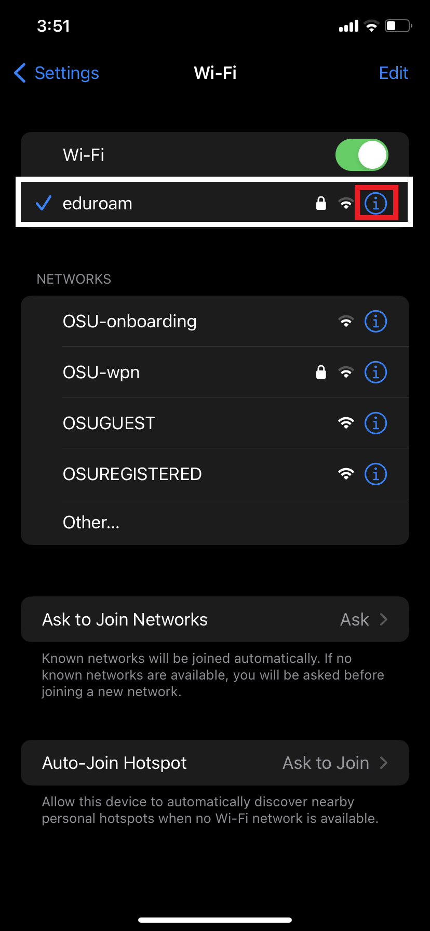

1. Under the Network Information, the IPv4 Address is listed next to **IP Address**.

