# How to Locate IPv4 Address on a Mac

# Details

An Internet Protocol (IP) address is a unique numerical value assigned to each network device. IP addresses are used for identifying and locating a device on a network.

On a device with both wired (Ethernet) and wireless (Wi-Fi) network connectivity capabilities, there will be one IPv4 Address for the wired (Ethernet) connection and another IPv4 Address for the wireless (Wi-Fi) connection. If a device only has wired (Ethernet) or wireless (Wi-Fi) network connectivity capabilities, then there will only be one IPv4 Address.

Instructions on how to locate:

* Wired (Ethernet) IPv4 Address
* Wireless (Wi-Fi) IPv4 Address

# How to Locate Wired (Ethernet) IPv4 Address:

1. Graphical user interface

   Description automatically generated with medium confidenceFrom the Desktop, click on the **System Preferences** gear icon.
2. Graphical user interface, application

   Description automatically generatedIn System Preferences, click on the **Network** icon.
3. 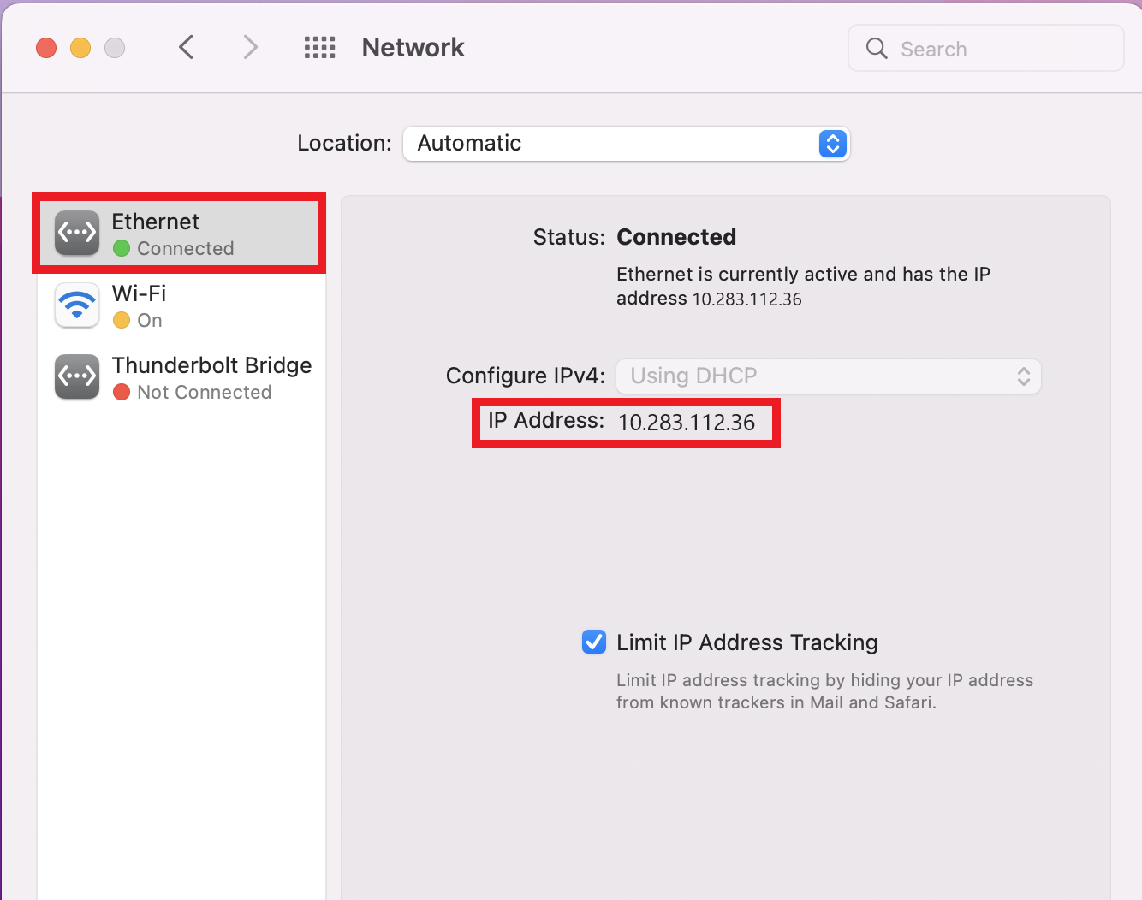On the **Ethernet** tab of the Network settings, the IPv4 Address is listed next to **IP Address**.

# How to Locate Wireless (Wi-Fi) IPv4 Address:

1. Graphical user interface

   Description automatically generated with medium confidenceFrom the Desktop, click on the **System Preferences** gear icon.
2. Graphical user interface, application

   Description automatically generatedIn System Preferences, click on the **Network** icon.
3. 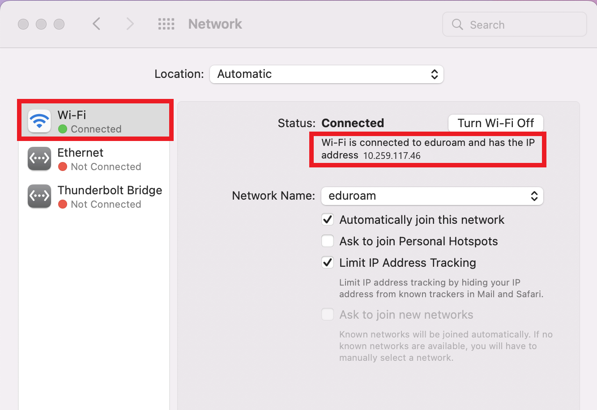On the **Wi-Fi** tab of the Network settings, the IPv4 Address is listed under connection status.