# How to Locate IPv4 Address on Windows 10

# Details

An Internet Protocol (IP) address is a unique numerical value assigned to each network device. IP addresses are used for identifying and locating a device on a network.

On a device with both wired (Ethernet) and wireless (Wi-Fi) network connectivity capabilities, there will be one IPv4 Address for the wired (Ethernet) connection and another IPv4 Address for the wireless (Wi-Fi) connection. If a device only has wired (Ethernet) or wireless (Wi-Fi) network connectivity capabilities, then there will only be one IPv4 Address.

Instructions on how to locate:

* Wired (Ethernet) IPv4 Address
* Wireless (Wi-Fi) IPv4 Address

# How to Locate Wired (Ethernet) IPv4 Address:

1. 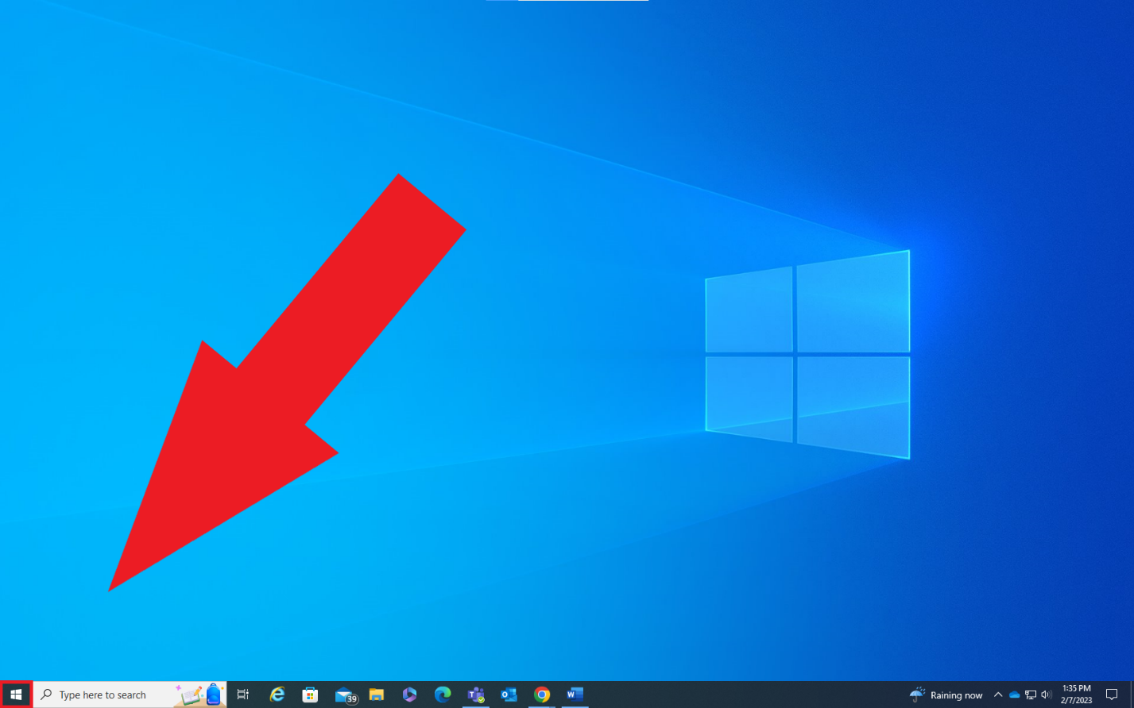From the desktop, click the Microsoft start icon in the bottom left-hand corner.
2. 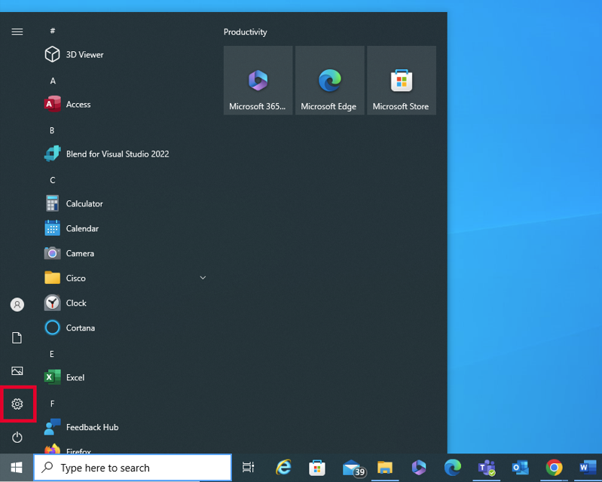Click the settings gear icon from the start menu.
3. 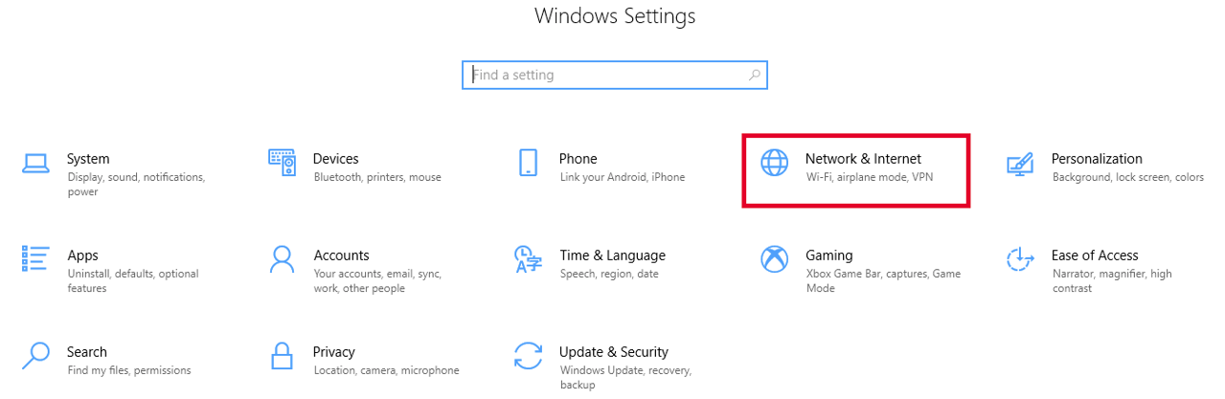In the Windows Settings, Click the **Network & Internet** tile.
4. On the Status tab, click the **View hardware and connection properties** link at the bottom of the page.

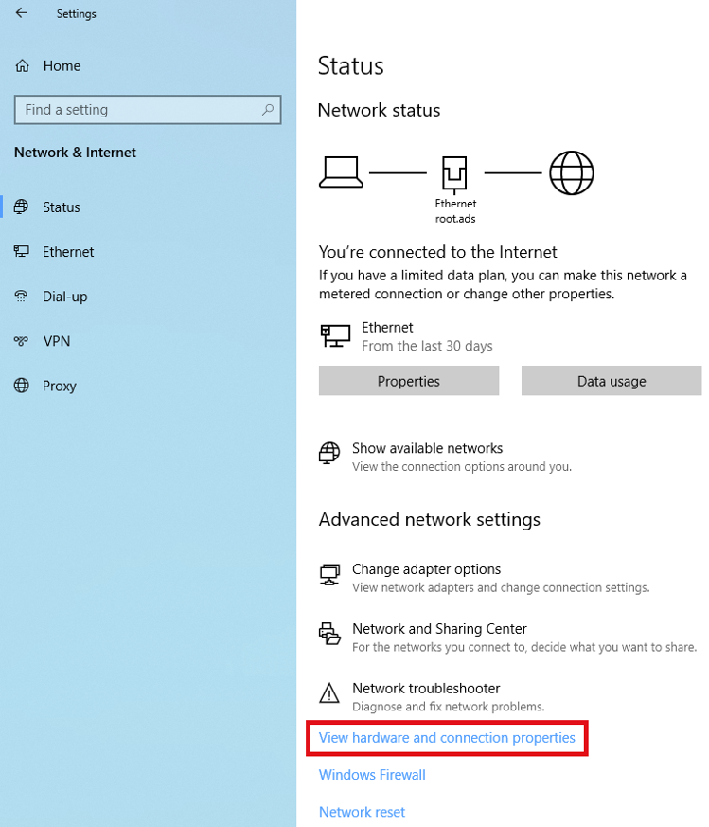

1. 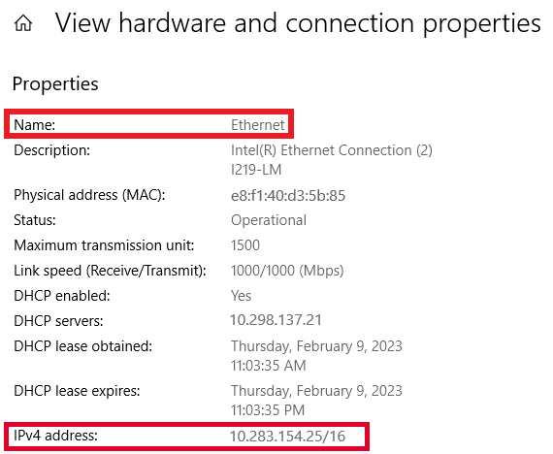Under the **Properties** section of the **View Hardware and Connection Properties** page, locate the **Ethernet** connection and the IPv4 Address is listed next to **IPv4 address:**

# How to Locate Wireless (Wi-Fi) IPv4 Address:

1. Icon

   Description automatically generated with low confidenceFrom the desktop, click the Microsoft start icon in the bottom left-hand corner.
2. Click the settings gear icon from the start menu.

1. Graphical user interface, application, Teams

   Description automatically generatedIn the Windows Settings, Click the **Network & Internet** tile.
2. On the Status tab, click the **View hardware and connection properties** link at the bottom of the page.

1. Under the **Properties** section of the **View Hardware and Connection Properties** page, locate the **Wi-Fi** connection and the IPv4 Address is listed next to **IPv4 address:**

