# How to locate IPv4 Address on Windows 11

# Details

An Internet Protocol (IP) address is a unique numerical value assigned to each network device. IP addresses are used for identifying and locating a device on a network.

On a device with both wired (Ethernet) and wireless (Wi-Fi) network connectivity capabilities, there will be one IPv4 Address for the wired (Ethernet) connection and another IPv4 Address for the wireless (Wi-Fi) connection. If a device only has wired (Ethernet) or wireless (Wi-Fi) network connectivity capabilities, then there will only be one IPv4 Address.

Instructions on how to locate:

* Wired (Ethernet) IPv4 Address
* Wireless (Wi-Fi) IPv4 Address

# How to Locate Wired (Ethernet) IPv4 Address:

1. A picture containing application

   Description automatically generatedOn the Desktop, click the Windows start icon.
2. A screenshot of a computer

   Description automatically generated with medium confidenceOpen device settings by clicking on the **Settings** gear icon.
3. Graphical user interface, application, Teams

   Description automatically generatedIn the settings menu, click the **Network & Internet** tab.
4. Graphical user interface, text, application, email, Teams

   Description automatically generatedOn the Network & Internet page, click the **Advanced Network Settings** tab.
5. Graphical user interface, text, application, email

   Description automatically generatedIn the Advanced Network Settings, click the **Hardware and Connection Properties** tab.
6. Under the **Hardware and Connection Properties** section, locate the **Ethernet** connection and the IPv4 Address is listed next to **IPv4 Address**.

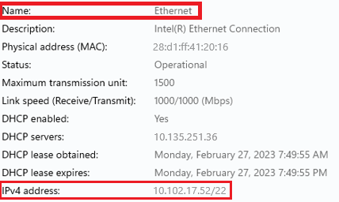

# How to Locate Wireless (Wi-Fi) IPv4 Address:

1. A picture containing application

   Description automatically generatedOn the Desktop, click the Windows start icon.
2. A screenshot of a computer

   Description automatically generated with medium confidenceOpen device settings by clicking on the **Settings** gear icon.
3. Graphical user interface, application, Teams

   Description automatically generatedIn the settings menu, click the **Network & Internet** tab.
4. Graphical user interface, text, application, email, Teams

   Description automatically generatedOn the Network & Internet page, click the **Advanced Network Settings** tab.
5. Graphical user interface, text, application, email

   Description automatically generatedIn the Advanced Network Settings, click the **Hardware and Connection Properties** tab.
6. 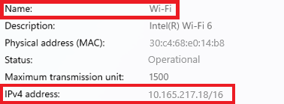Under the **Hardware and Connection Properties** section, locate the **Wi-Fi** connection and the IPv4 Address is listed next to **IPv4 Address**.