VoIP Common User Options

Login to your Unified Communications Self Care Portal

Modify your Device Settings

Configure Call Forwarding

Login to your Cisco Unified Self Care Portal
To access your VoIP User Options you may need to contact Telecom (4-4357 or telecomm@okstate.edu) and request that your new VoIP device is associated with your.okstate.edu email account in the VoIP phone system.
- Open your favorite internet browser and navigate to http://cucm.net.okstate.edu/ccmuser .

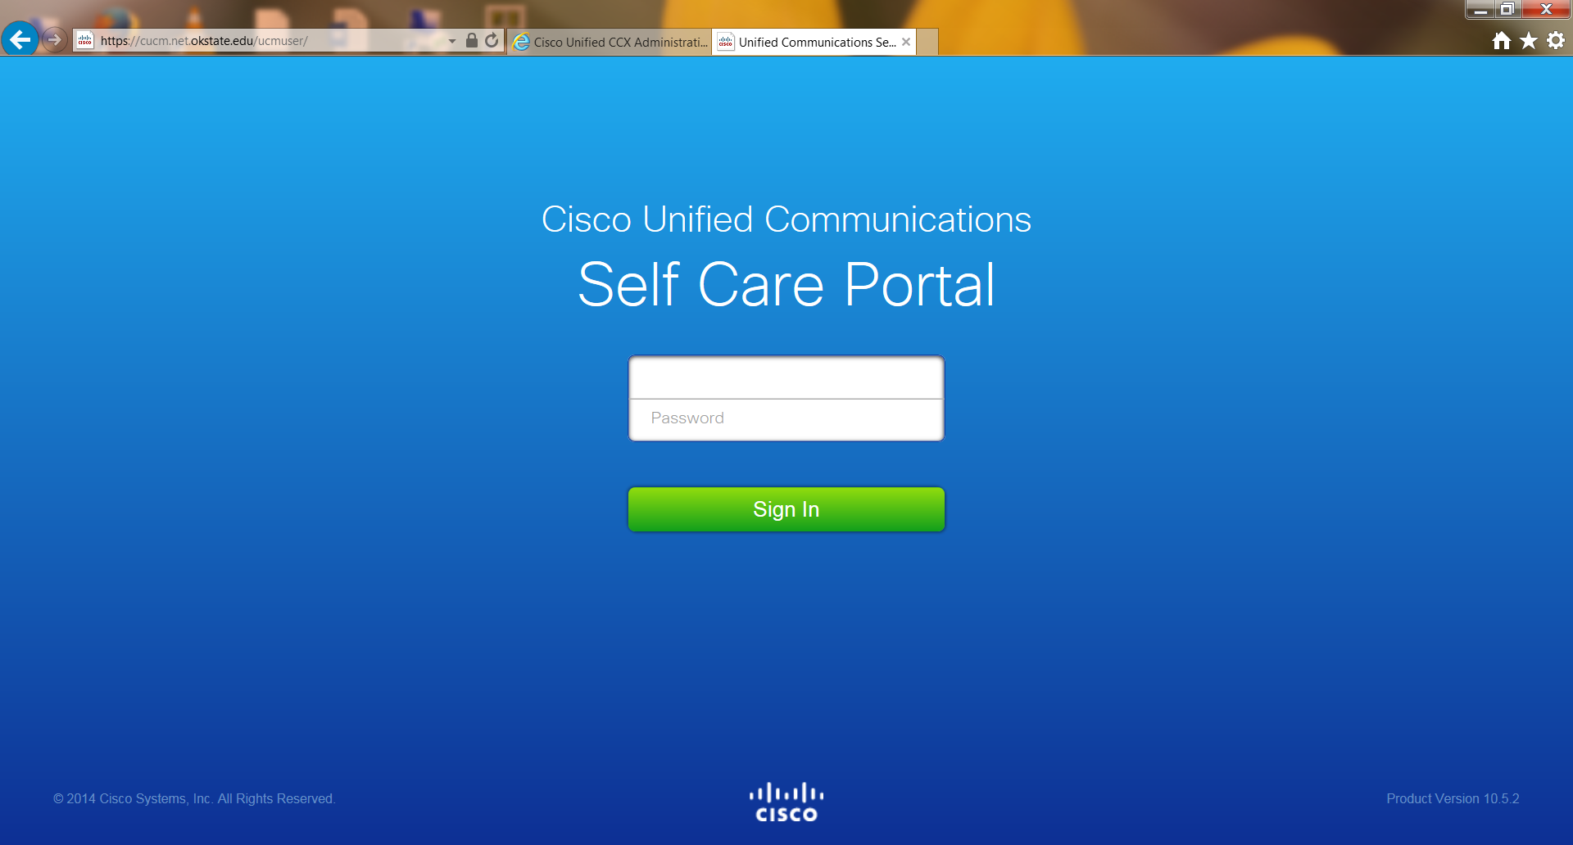

- Enter your Username (Use your okstate.edu email) and OKEY Password.
- Click Login.
- You should now see the following page:
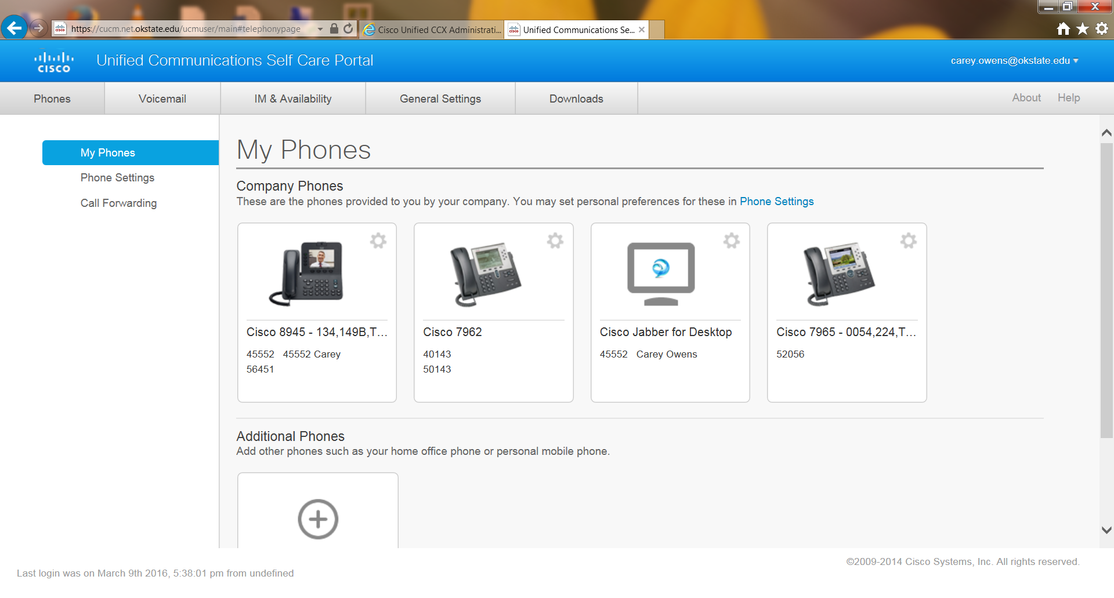
This is a list of all devices that are assigned to you. You can click on the device and a dialog box will pop up that would allow you to edit the device, change the settings (a process that is covered later in this document) and download the manual for this device type. You may edit/add a label for each line on your device.
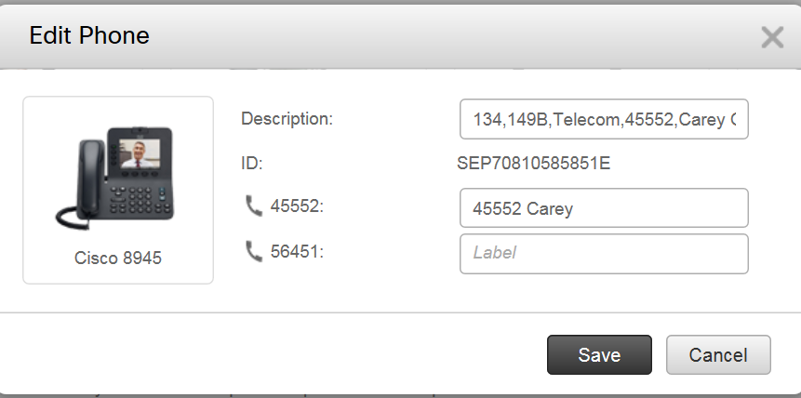

Modify your Device Settings
- Navigate in the left menu to “Phone Settings”.
- To add/modify/delete speed dial numbers, expand the “Speed Dial Numbers” option in the list.
- The page will then resemble the screen shot below: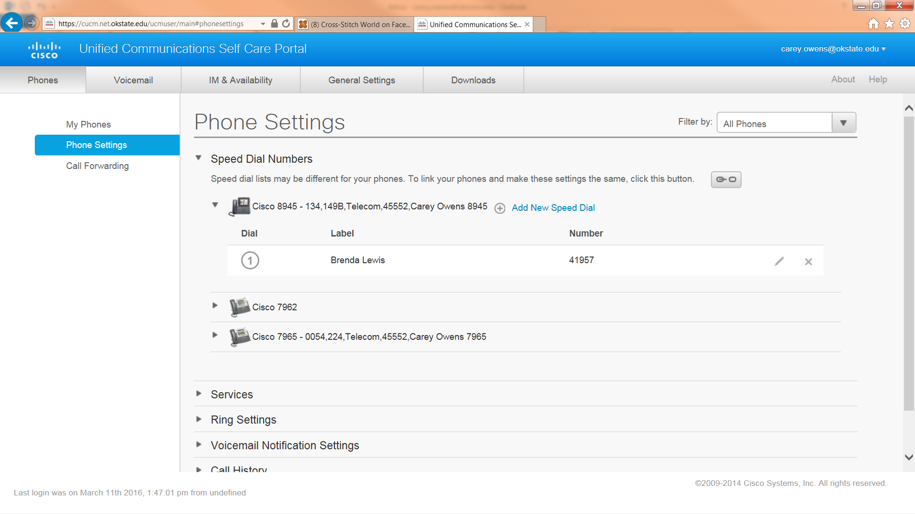
- To add new speed dial numbers click the + Add New Speed Dial link.
- A new dialog box will pop up that looks like this:
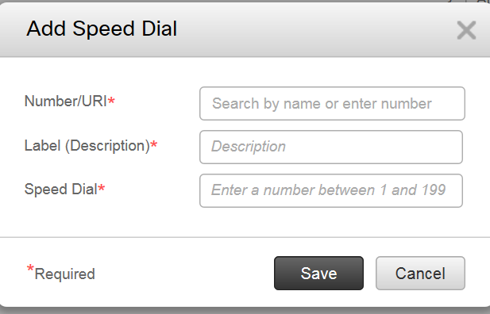

- For each speed dial button enter the Number and the Label for the contact and the next entry in your list of speed dial buttons.
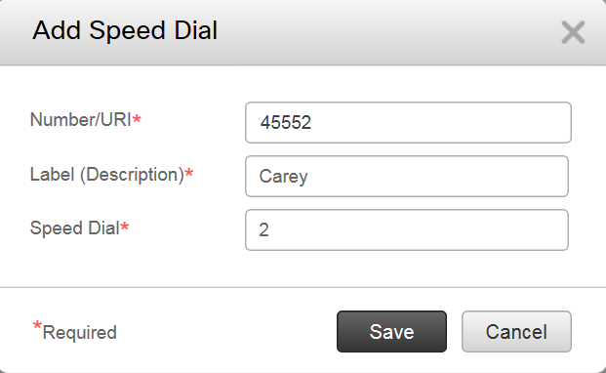
(NOTE: Be sure to include (8) before for off-campus numbers.)
- Click Save.

Configure Call Forwarding
- From the left menu click on Call Forwarding .
- The next screen will look like this: 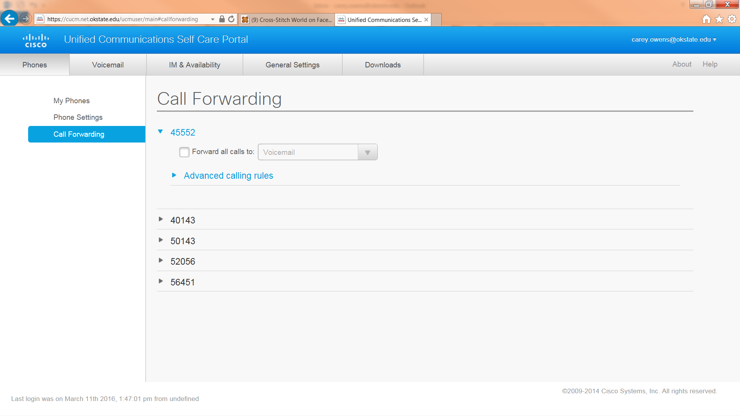
- Expand the information for the line you wish to forward:

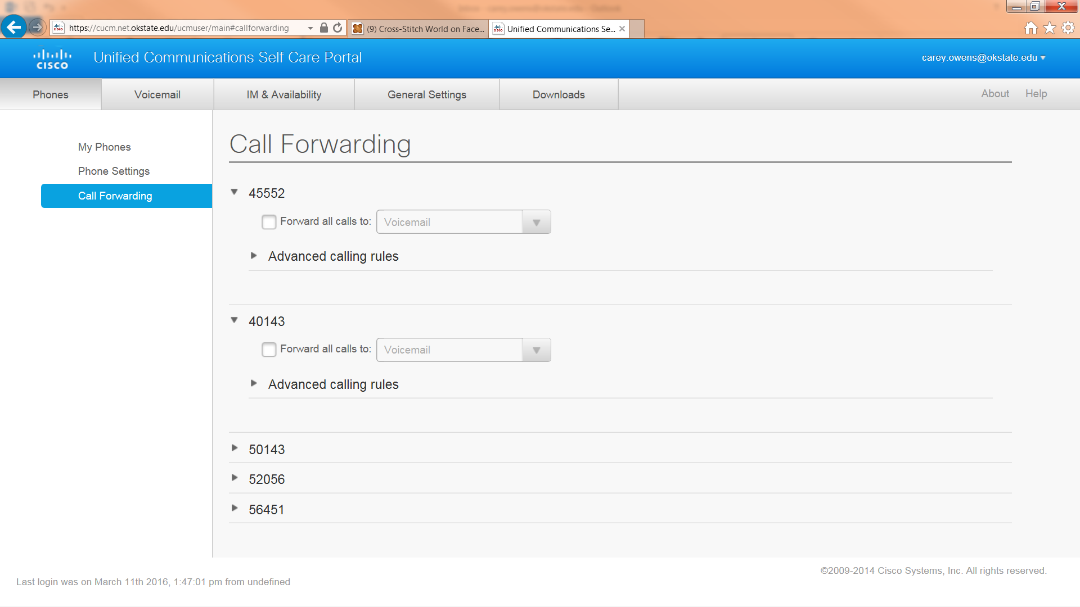

- You may either just choose to forward all calls by clicking the box or you can choose to have different types of calls go to different numbers.

